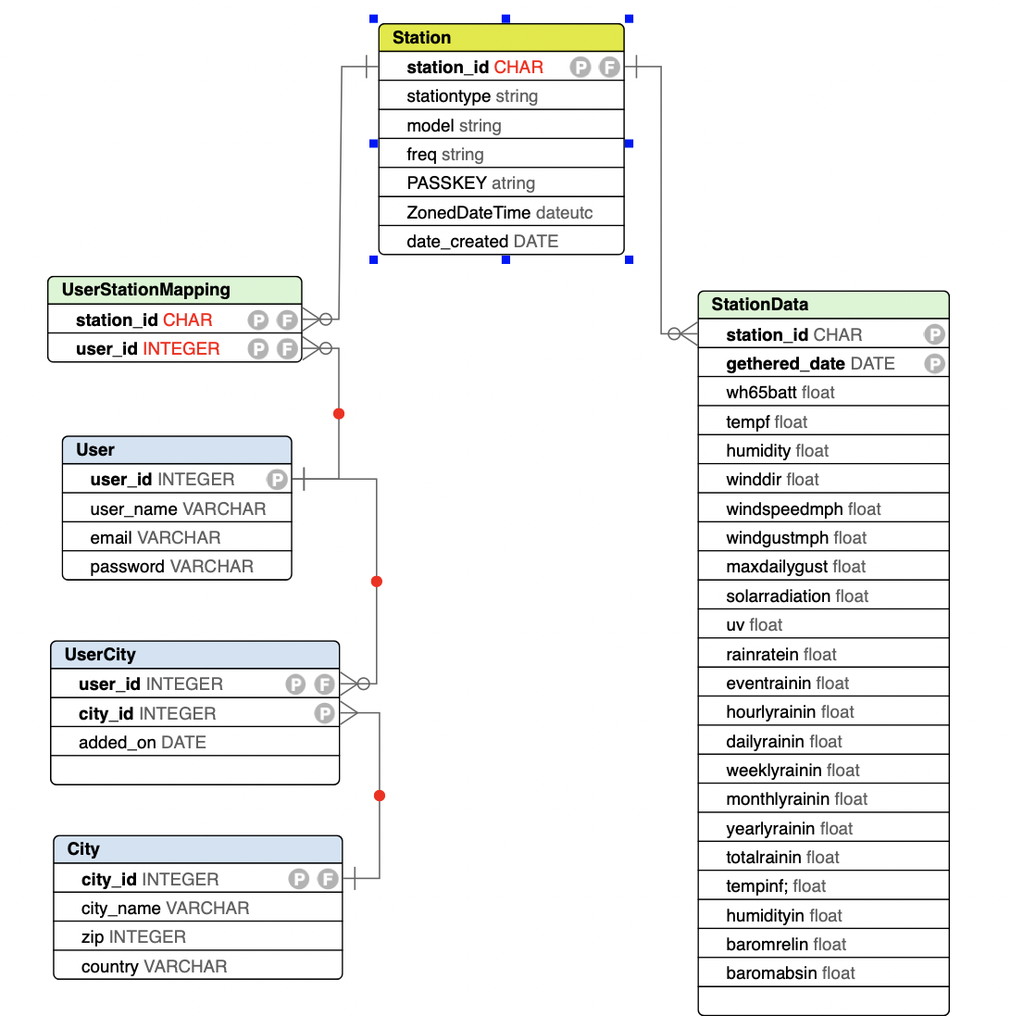

I’ve split the model into three subject areas:

* Station Info
* User Info
* Station data

Station data

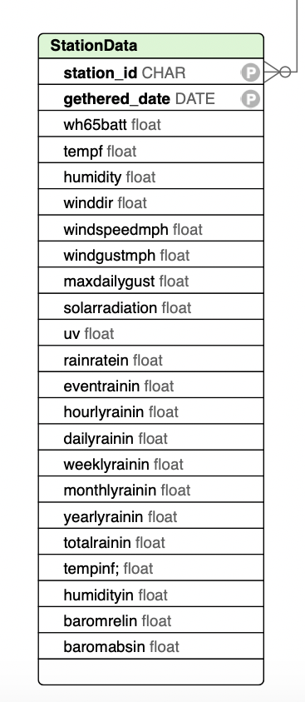

This is the most important subject area. Any weather app should capture these basic details:

* Date when information was gathered
* Temperature inside
* Humidity
* Direction of wind
* Wind speed in mph
* Wind gust in mph
* Maximum daily gust
* Solar radiation
* Ultraviolet radiation
* Rain rate in inches
* Hourly raining
* Daily raining
* Weekly raining
* Monthly raining
* Yearly raining
* Total raining
* Temp outside
* Humidity
* Barometric pressure

Together, these give a holistic view of current weather condition. This is the information that will be presented to users, usually through one or more intuitive screens.

User Info

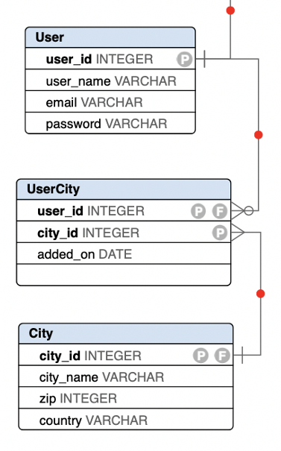

This subject area mainly handles user’s location information. Most of the columns are self-explanatory, so we will just briefly explain the purpose of each table.

The User table holds basic info about users, like email address and password. The user_id column assigns a unique number to every user who registers with the application.

The UserCity table is just in between of many to many relationship of User and City tables.

The City stores a list of cities and their location details (postal code, country). The columns in this table are self-explanatory.

Station Info

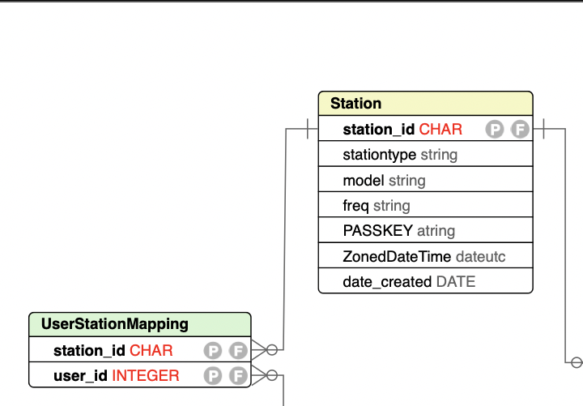

The UserStationMapping table maps the relationship between users and Stations.

Since the application allows users to monitor the weather in as many cities as they want, this subject area handles associating one or more cities with each user’s profile.

The Station table stores a list of stations with their model details, Passkeys, station types, dates created, Time zones and frequency of getting data.

SQL Part

CREATE TABLE StationData

(

station_id CHAR,

gethered_date DATE,

wh65batt FLOAT,

tempf FLOAT,

humidity FLOAT,

winddir FLOAT,

windspeedmph FLOAT,

windgustmph FLOAT,

maxdailygust FLOAT,

solarradiation FLOAT,

uv FLOAT,

rainratein FLOAT,

eventrainin FLOAT,

hourlyrainin FLOAT,

dailyrainin FLOAT,

weeklyrainin FLOAT,

monthlyrainin FLOAT,

yearlyrainin FLOAT,

totalrainin FLOAT,

tempinf; FLOAT,

humidityin FLOAT,

baromrelin FLOAT,

baromabsin FLOAT,

CONSTRAINT StationData_pkey PRIMARY KEY (station_id,gethered_date)

);

CREATE TABLE Station

(

station_id CHAR,

stationtype STRING,

model STRING,

freq STRING,

PASSKEY ATRING,

ZonedDateTime DATEUTC,

date_created DATE,

CONSTRAINT Station_pkey PRIMARY KEY (station_id)

);

CREATE TABLE 'User'

(

user_id INTEGER,

user_name VARCHAR,

email VARCHAR,

password VARCHAR,

CONSTRAINT User_pkey PRIMARY KEY (user_id)

);

CREATE TABLE UserCity

(

user_id INTEGER,

city_id INTEGER,

added_on DATE,

CONSTRAINT UserCity_pkey PRIMARY KEY (user_id,city_id)

);

CREATE TABLE City

(

city_id INTEGER,

city_name VARCHAR,

zip INTEGER,

country VARCHAR,

CONSTRAINT City_pkey PRIMARY KEY (city_id)

);

CREATE TABLE UserStationMapping

(

station_id CHAR,

user_id INTEGER,

CONSTRAINT UserStationMapping_pkey PRIMARY KEY (station_id,user_id)

);

ALTER TABLE Station ADD FOREIGN KEY (station_id) REFERENCES StationData (station_id);

ALTER TABLE UserCity ADD FOREIGN KEY (user_id) REFERENCES 'User' (user_id);

ALTER TABLE City ADD FOREIGN KEY (city_id) REFERENCES UserCity (city_id);

ALTER TABLE UserStationMapping ADD FOREIGN KEY (station_id) REFERENCES Station (station_id);

ALTER TABLE UserStationMapping ADD FOREIGN KEY (user_id) REFERENCES 'User' (user_id);